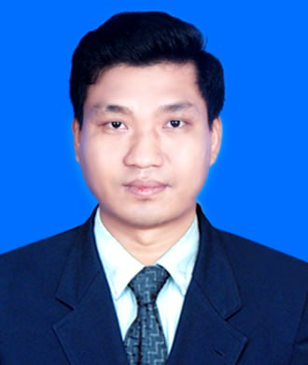
TIN MAUNG WIN

SERVICE TECHNICIAN
Dependability and Experience Professional in Mechanical field to perform Overhaul, Servicing ,Troubleshooting, Installation and Maintenance works to take on additional duty to accomplish deadlines.


DOB 6/11/1989
Passport No MG 626210
Nationality Myanmar
Marital Status Single
Availability Immediately
Expected salary SGD2500 (Nego:)
Contact

iniInInfoInformation

Experience


Hlaingtharyar Tsp, Yangon.
tinmaungwinn86@gmail.com
+959250951464 (WhatsApp)

Workshop Supervisor Jan 2020to June 2022
UMW Engineering Services Company Limited Hpakant, Myanmar
Duties and Responsibilities,
- Assembled Diesel engine & Troubleshooting and QC checked
- Took photo record of receiving condition from customer before disassembling Engine and Hydraulic Components
- Measured and inspected the parts of engines according to shop manual and filled check-sheet after disassemble of Engine.
- Prepared parts recommendation to customer for damage/wear parts.
- Assembled the Engine with standard procedure.
- Performed testing such as measuring Engine Oil Pressure , Checking Engine Sound, Fuel leakage, Oil Leakage.,and Troubleshooting after assembly Engine
- Took part in challenging and problem-solving job.
- Reported all operation activities to After sale Service Manager.

Service Technician Jan 2017 to Dec 2019
UMW Engineering Services Company Limited Hpakant, Myanmar
Duties and Responsibilities,
- Repaired all problem failure deals with heavy machinery machine (espically in KOMATSU Excavator & DumpTruck) and other heavy Equipment.
- Handled workshop Job ( Engines Overhaul and Hydraulic Pump, Control Valve, Motor,Swivel Joint, Hydraulic Cylinders, Water Pump and Transmission and Transmission Pump Overhaul) and field job also.
- Prepared Service Bulletin by monthly and sent to manager.
- Functioned machine population list update by doing regular maintenance on machine Hpakant Area.
- Ensured continuous improvement in Safety, Efficiency, Performance, Cost-Effectiveness in Workshop operations.
- Managed workshop operations and ensured Key Performance Indicators (KPI) are met
- Reported all Problem Failure to service manager.





Personal info

Personal Skills
- Able to work Under Pressure
- Physically and mentally strong
- Possess Driving License
- Interpersonal Skill
- Fast Learner & Problem- Solving
- Decision Making
- Detail Oriented
- Good at Time Management

Computer Skill

- Microsoft Office
(Word, Excel & Power Point)
- Internet & Email

Language
Experience

Professional Experience

Academic background d
Academic background
Maintenance Technician Dec 2014 to Dec 2016
UMW Engineering Services Company Limited Hpakant, Myanmar
Duties and Responsibilities,
- Ensured scheduled activities to perform that machinery is in good working order at all times
- Tested PDI&DI when the machine delievers to customer.
- Performed preventive maintenance such as Replaced Fuel filter , Engine oil filter, Hydraulic filter for every 500, 1000, 2000 hours and changed Engine oil ,Coolant, hydraulic oil and TO30
- Checked before operation(Engine oil level, Coolant level, Intake/Exhaust system, Fuel system).
- Inspected machine by using checklists, including belts,Work Equipments, Mechanical system, Electrical system, fuels system.
- Evluated possible causes of Machinery failures and troubleshooting Hydraulic System,Wiring Systems ,testing and adjusting, repairing.
- Reported to all job activities to manager.

- English (Intermediate)
- Burmese (Native)

Techanical Training

- Komatsu Excavator TechnicaTraining
- Dump Truck Technical Training (HD785-7R, HD467-7R)
- CRI Engine Technical Training
- Safety Training
- 5S Training
- Business Management Training

Summary

Academic Education
Looking for a challenging role in a reputed Company to Utilize about
7 years Engineering skills, troubleshooting engine, hydraulic system, wiring system, overhaul engine and hydraulic components, machine installations and repairing skills that can contribute to the company’s growth as well as enhance my knowledge by exploring new things.
I hereby declare that all above information is true and correct one.
Sincerely,
Mr. Tin Maung Win
tinmaungwinn86@gmail.com
+959 250951464(WhatsApp)

- Bachelor of Engineering (Mechnical)
Technological University (Magway)

Project Photos
Engine Assembly

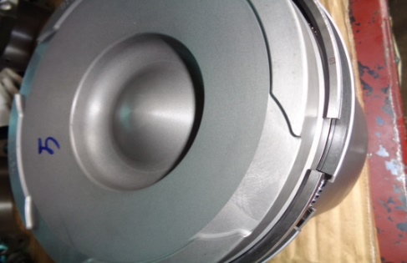
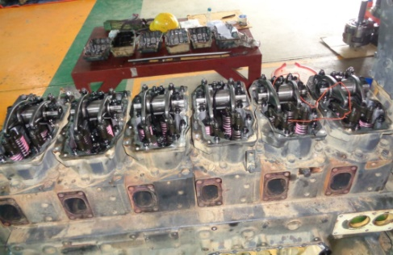

Disassemble Engine
Already Install Piston Ring

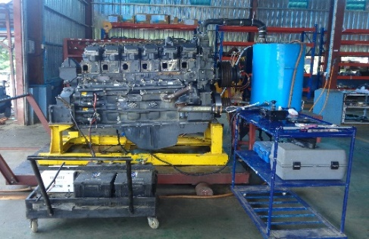
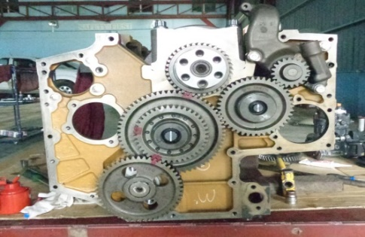
Already Install Idler Gear

After Assemble Finish Test Run Engine

